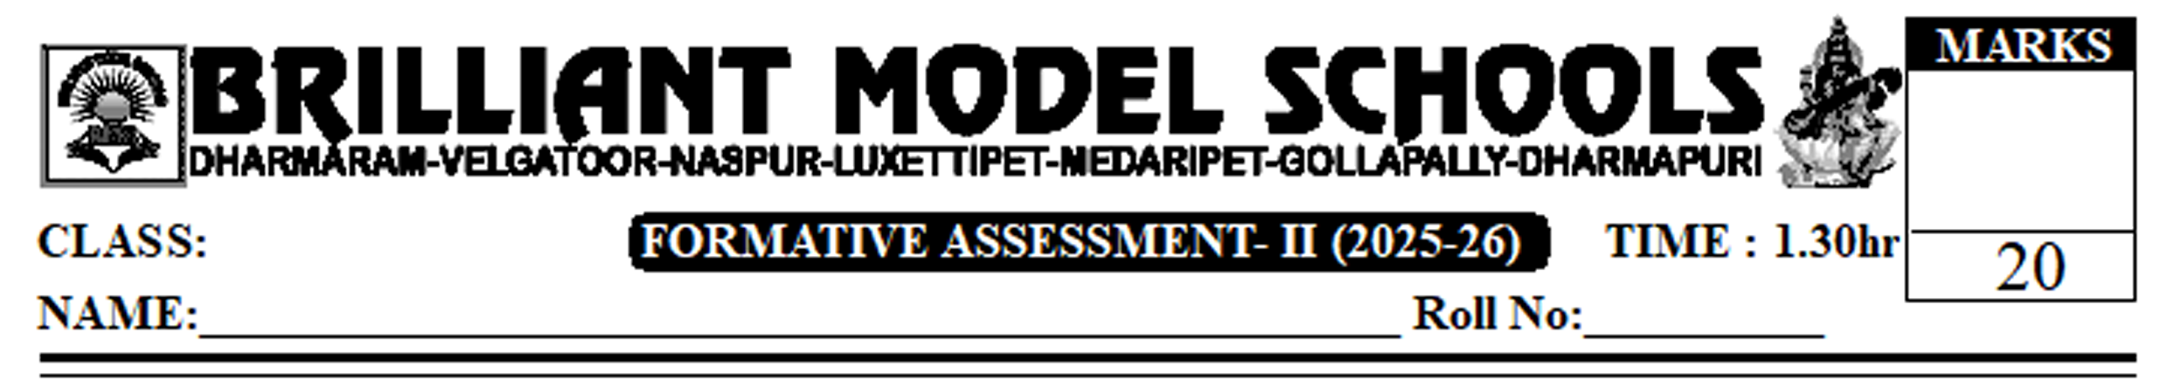

VI English

Section A: Reading Comprehension
I. Read the following passage.
When Tess heard her daddy say to her tearful mother, "only a miracle can save him now", she went to her room and pulled a jar of coins from a cupboard. She poured all the money out on the floor and counted it carefully. Holding the jar tightly, she made her way to the medical store and placed it on the glass table.
"What do you want?" asked the chemist, "it's for my little brother", Tess answered, "he's really, really sick and I want to buy a miracle."
"We don't sell miracles here, child. I'm sorry." The chemist said, smiling sadly at the little girl. "Listen, I have the money to pay for it, if it isn't enough, I can try and get some more. Just tell me how much it costs."
Choose the correct answer and write (A), (B), (C), or (D) in your answer booklet. 3x1=3
- A chemist is a___________________. ( )
- shopkeeper B) Doctor C) shop owner D) patient
2. Tess thought a "miracle" might be______________. ( )
A) some medicine B) a jar C) money D) None
3. Tess heard the sickness of his brother from____________. ( )
A) her mother B) her father C) Both D) a chemist.
Answer the following questions in two or three sentences each. 2x1=2
4. What did she take with her to the chemist shop?
5. If you were in the place of Tess, what would you do?
Section B: Vocabulary and Grammar.
II. Read the following passage and write as directed. 5x1/2=2.5
Wilma Rudolph was born (17) in a poor (18) family in Tennessee. In (19) the age of four, she had pneumonia with scarlet fever which left her (20) paralyzed with polio. She had to wear (21) a brace and the doctor said she would never put her foot on earth.
Answer the following Questions
6. write the antonym of the underlined word.
7. write the other form of the underlined word.
8. Replace the underlined word with the right one.
9. write the synonym of the underlined word.
10. write the other verb's form of the underlined word.

III. Read the passage given below: Five sentences in the passage are numbered. Each of these sentence has an error. Correct and Re-write them. 5x1=5.

11)There was not reply. 12) Seema could not saw anyone. 13) she was about to enter the cave when she caught sight of a piece of torn crumpled paper in the ground. 14) the pick it up and unfolded it out. 15) How old is it had letters like wrote on it!
Section C: Conventions of writing.
IV. Rewrite the following sentence using proper punctuation and capitalization 1x2.5=2.5
16. That surgery her mum whispered was a real miracle I wonder how much it would have cost. Section D: Creative writing. 1x5=5
17. Write a possible conversation between Arun/Seema and Grandmother/Grandmother, after the departure of police officers.
18. Prepare a poster titled "save water".

